FCS PTO Meeting Minutes
June 10, 2020 called to order @ 6:36 pm on Zoom
Attendance: Bonnie Wagner, Sandy Thompson, Kim Cockle, Laura Sisson, Stacy Strickland
Welcome- Bonnie Wagner
Review February Minutes & approve for record
Motion to approve by: Laura S. Second by: Stacy S.
Treasurer’s Report- Stacy Strickland
Balance- $ 2.900
Current Events
Senior Gift Bags- Handed out Bracelets, Tote bags and Cards to Seniors at “Senior Parade”.
Micro Pantries-Grants totaling $2,000 is being used on food, hygiene items, and phone cards
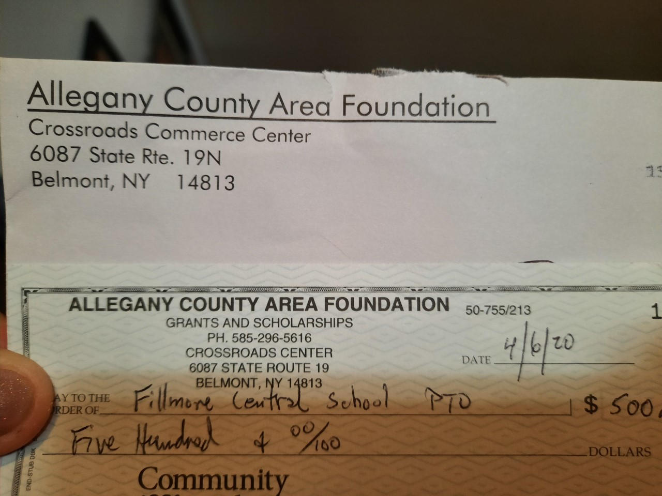
- Centerville- Bonnie Wagner and Caleb will buy for and keep stocked.
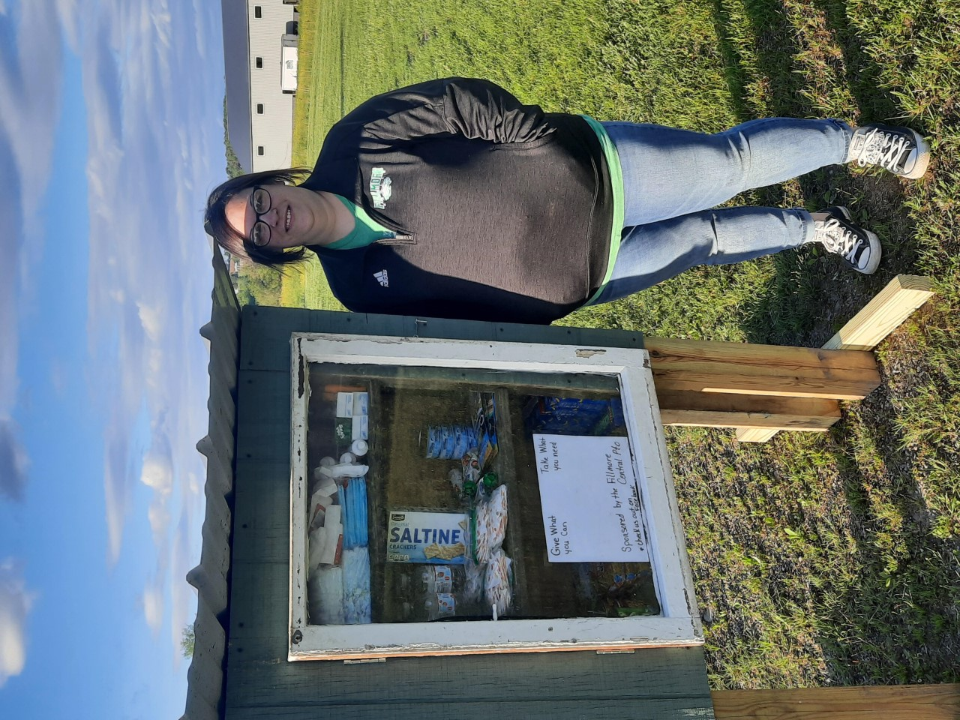
- Short Tract- Kim Cockle will buy for and keep stocked
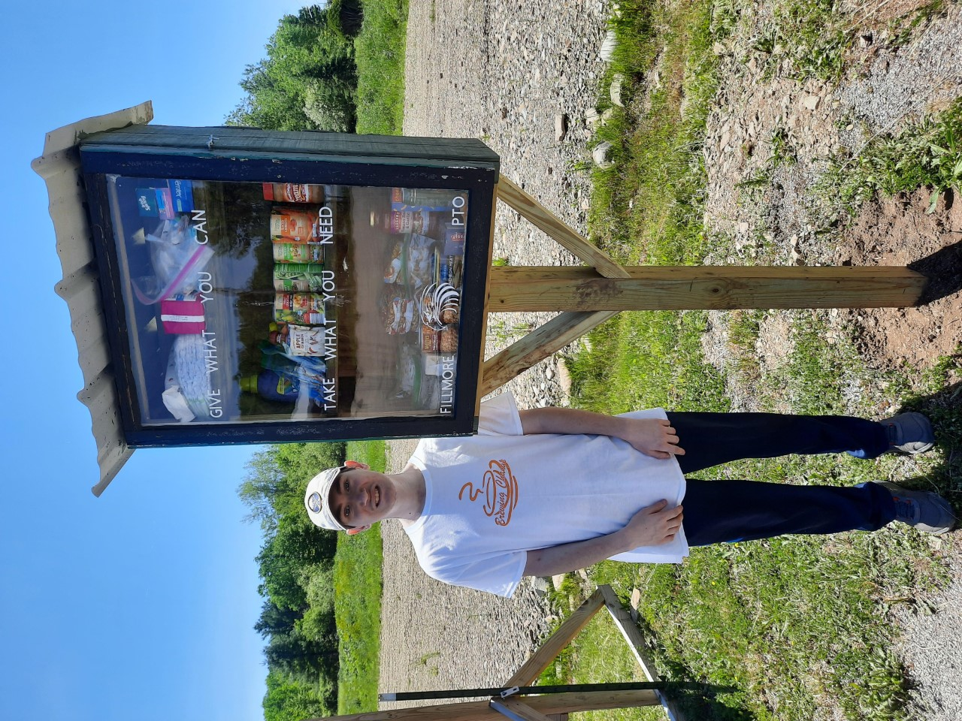
- Houghton- Laura Sisson and Stacy Strickland will buy for and keep stocked
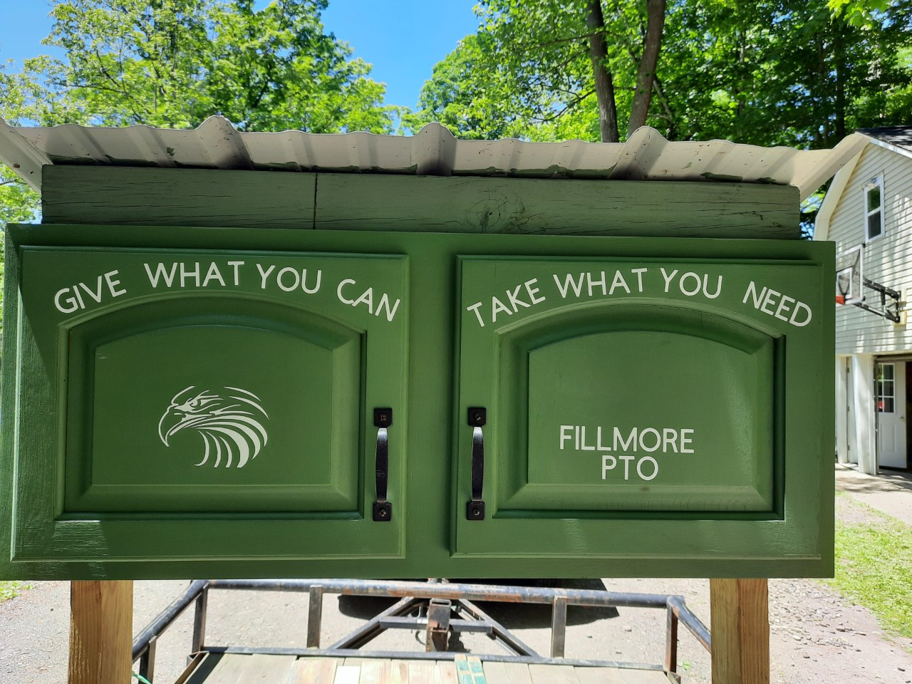
- Wiscoy/Rossburg-Awaiting final Approval-waiting to hear back from M. Hopkins
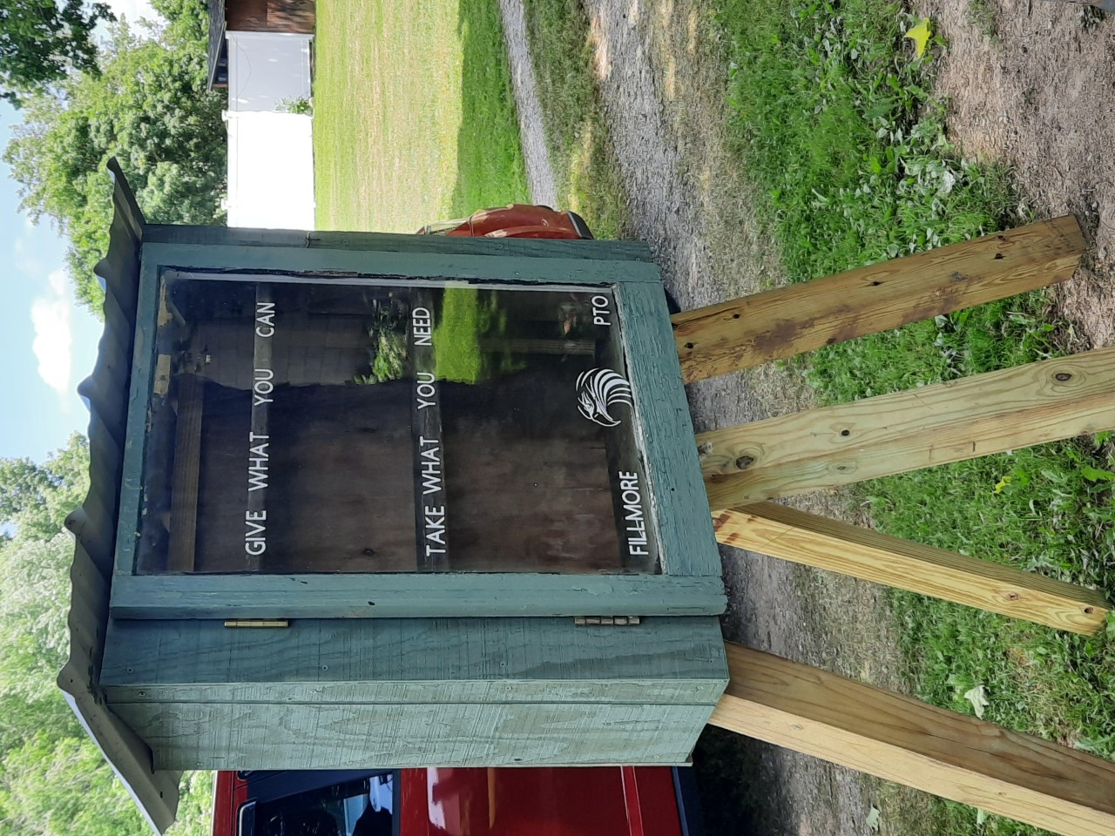
Teacher Appreciation Week
- Paired with Administration and created Staff bags for pickup
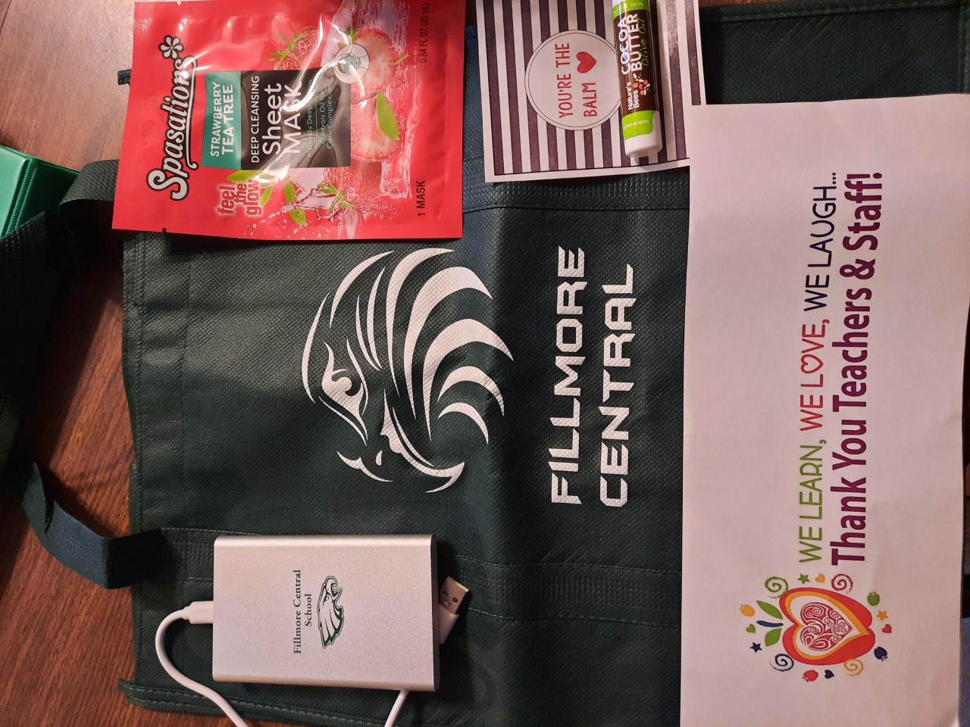

Administration Updates: none
Open Floor: none
Motion to adjourn by Laura S. Second by: Kim C
Adjourned at: 7:11pm
Next Meeting: August to set up meetings for the Fall, potential of Zoom meetings at 6:30 pm on 2nd Wednesday of the Month was discussed. We will look at the school Calendar and Board Meetings to see how they coincide.

